HAMILTON <= TSP
Travelling Salesperson Problem
Given a set of cities and distance between every pair of cities, the problem is to find the shortest possible route that visits every city exactly once and returns to the starting point. It is an NP-hard problem. In simple words, it means you can not guarantee to find the shortest path within a reasonable time limit. Note the difference between Hamiltonian Cycle and TSP. The Hamiltonian cycle problem is to find if there exist a tour that visits every city exactly once. Here we know that Hamiltonian Tour exists (because the graph is complete) and in fact many such tours exist, the problem is to find a minimum weight Hamiltonian Cycle.
- For example, consider the graph shown below.
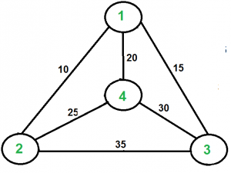
- Start point is 1.
- A TSP tour in the graph is 1-2-4-3-1.
- So Output of Given Graph: minimum weight Hamiltonian Cycle : 10 + 25 + 30 + 15 := 80
Some different solutions for the Traveling Salesperson Problem are the Brute Force Approach, the Nearest Neighbor Approach, Christofides Algorithm.
Concrete Examples
The TSP has several applications even in its purest formulation, such as planning, logistics, and the manufacture of microchips. Slightly modified, it appears as a sub-problem in many areas, such as DNA sequencing. In these applications, the concept city represents, for example, customers, soldering points, or DNA fragments, and the concept distance represents travelling times or cost, or a similarity measure between DNA fragments
Reduction of the Hamiltonian Cycle Problem to the Travelling Salesperson Problem
To reduce the Hamiltonian Cycle Problem to the Travelling Salesperson Problem for a given graph G=(V, E), complete the graph G, by adding edges between all pairs of vertices that were not connected in G. Let the new graph be G’=(V’, E’) where V’=V and E’={(u,v)} for any u,v Î V’.
For edges in G’ that were also present in G, we assign a weight 0. For other edges we assign weight 1.
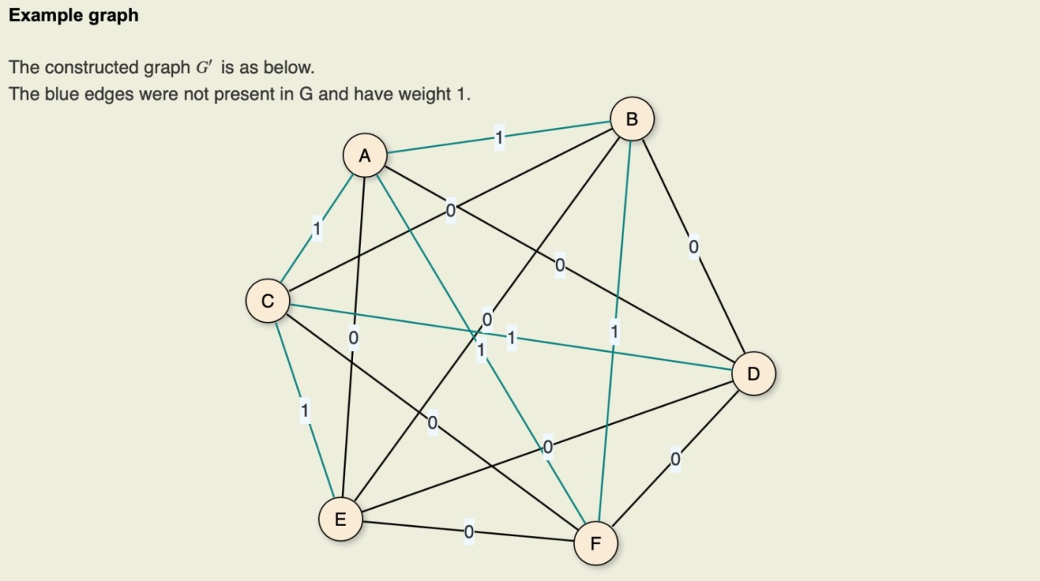
The graph G has a Hamiltonian Cycle if and only if there exists a cycle in G’ passing through all vertices exactly once, and that has a length <= 0
- If there is a cycle that passes through all vertices exactly once, and has length <= 0 in graph G’, the cycle contains only edges that were originally present in graph G. Hence there exist a Hamiltonian Cycle in G.
- If there exists a Hamiltonian cycle in the graph G, it forms a cycle in G’ with length=0, since a weights of all the edges is 0. Hence there exists a solution for Travelling Salesperson Problem in G’ with lengt <= 0.
